**Jorge’s Great Day!**

**Name: ______________________ Date: ____________**

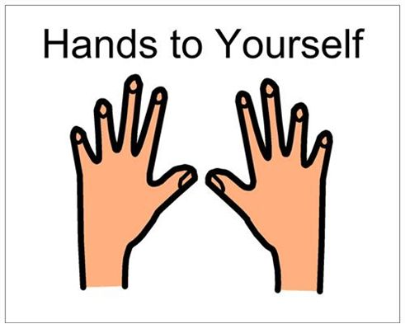

5  and 0  = Reward

**0 times =** 

**1-2 times =** 

**3 or more times =** 

|  |  |
| --- | --- |
| **Morning Routine** | Happy Face http://www.clker.com/cliparts/a/t/o/5/s/n/unsure-smiley-face-hi.png Sad face |
| **Math** | Happy Face http://www.clker.com/cliparts/a/t/o/5/s/n/unsure-smiley-face-hi.png Sad face |
| **Specials** | Happy Face http://www.clker.com/cliparts/a/t/o/5/s/n/unsure-smiley-face-hi.png Sad face |
| **Listening and Learning** | Happy Face http://www.clker.com/cliparts/a/t/o/5/s/n/unsure-smiley-face-hi.png Sad face |
| **Lunch** | Happy Face http://www.clker.com/cliparts/a/t/o/5/s/n/unsure-smiley-face-hi.png Sad face |
| **Skills Strand and GRAIR** | Happy Face http://www.clker.com/cliparts/a/t/o/5/s/n/unsure-smiley-face-hi.png Sad face |
| **Recess** | Happy Face http://www.clker.com/cliparts/a/t/o/5/s/n/unsure-smiley-face-hi.png Sad face |